**Screen Shots with Description**

Step 1:

Run the project and this Form1 will appear for you.

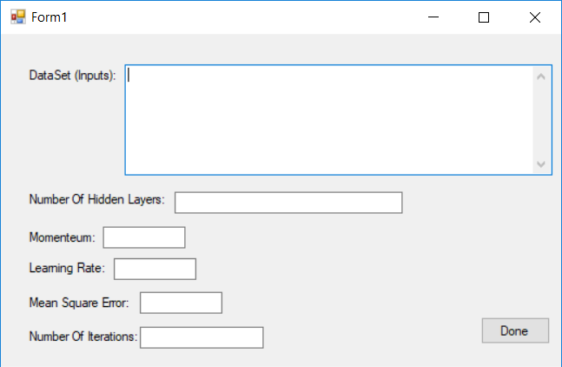

Step 2:

Copy the highlighted Dataset and paste them in the Data Set (Inputs): text box as shown in the image.

For Example: in the image, we have 3 inputs values and 1 desired value

(Input 1 Input 2 Input 3 Desired)

Note: it must be at least one space between the numbers, to separate the number of nodes of each hidden layer.

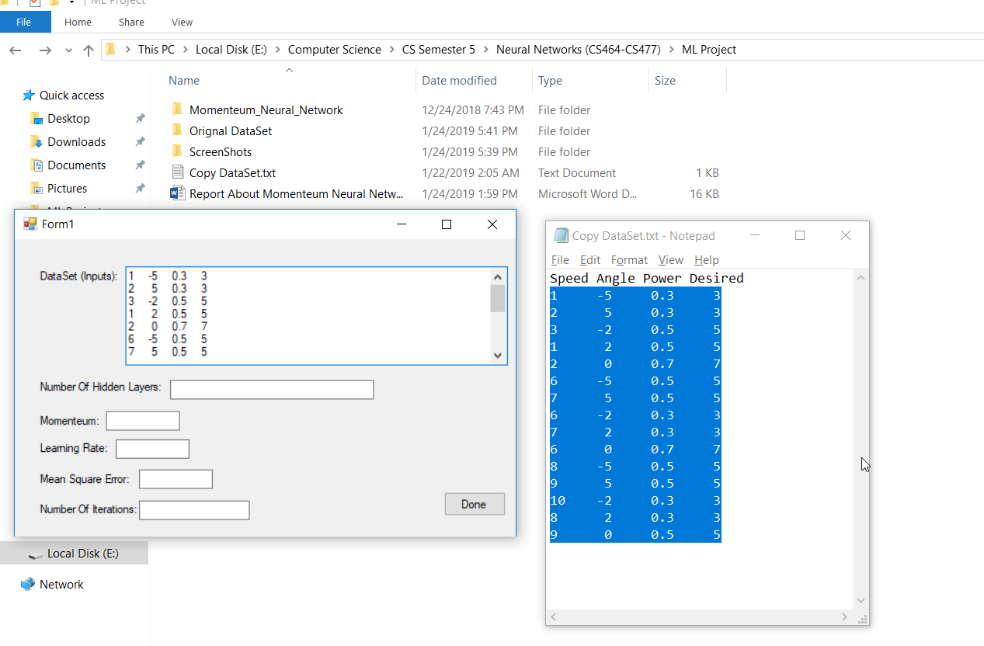

Step 3:

Enter number of hidden layers in the second TextBox.

For example: 3 2 mean that we have 2 hidden layers the first one has 3 nodes and the second one has 2 nodes.

Note: it must be at least one space between the numbers, to separate the number of nodes of each hidden layer.

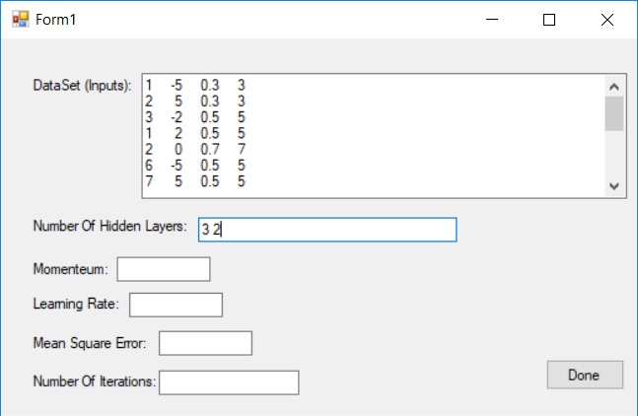

Step 4:

Enter the Momentum factor value in the third TextBox.

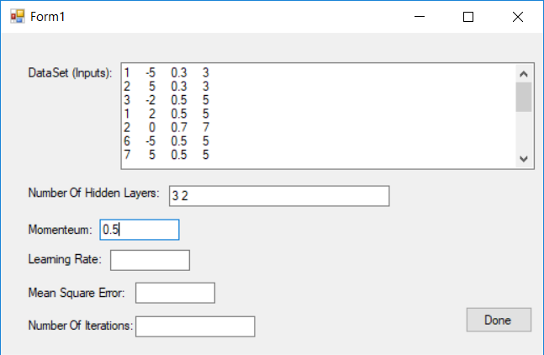

Step 5:

Enter the Learning Rate value in the fourth TextBox.

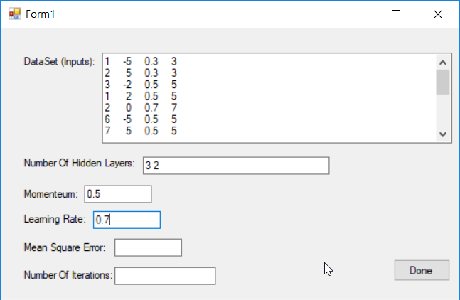

Step 6:

Enter the Mean Square Error value in the fifth TextBox.

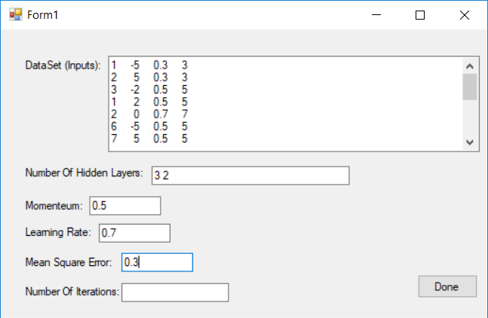

Step 7:

Enter number of iterations value in the sixth TextBox.

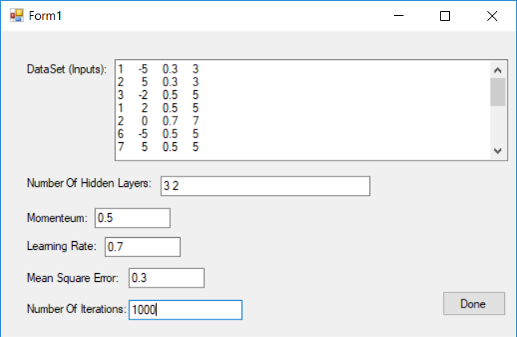

Step 8:

Press on Done Button and wait a while until Form2 appear with the final weights values and the accuracy of tested samples.

Note: My dataset are very small, so I used leave-one-out-cross-validation method where it is used when the data set is very small. It is a special case of cross validation. Each fold of the cross validation has only a single test example and all the rest of the data is used in training. If the original data has m examples (samples), this is m-fold-cross-validation.

